Application of Quadratics

1. Find the volume of the rectangular prism shown below

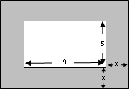
2. Describe the area of the shaded region as a polynomial

Solve the applications that of QUADRATIC EQUATIONS:

- The length of a rectangle is 1 cm more than twice its width. If the area of the rectangle is 21cm² then what are the dimensions?
- The length of a rectangle is 3 cm less than twice its width. If the area of the rectangle is 20cm² then what are the dimensions?

- The volume of the prism is 28 cubic inches. What is the length of each side?

- The volume of the prism is 45 cubic inches. What is the length of each side?

- A picture frame is shown at the right. If the entire area of the frame and the picture totals 120 square inches find the width of the frame.
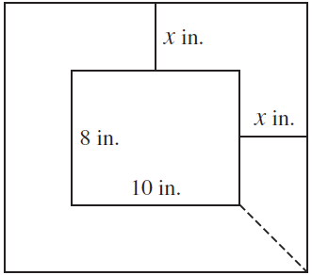

- A below ground swimming pool is to be constructed in the park. The pool is in the shape of a rectangle with the dimensions of 20’ by 24’. A uniform width sidewalk is to be made around the pool. If the contractor says that he has enough concrete to create 300 ft² of sidewalk. What is the maximum width of the sidewalk around the pool?

- The product of two consecutive positive integers is 132. Write an equation to model the situation and find the two integers.

- The perimeter of a rectangle is 42 cm and the area is 80 cm². Write an equation to model the situation and find the dimensions of the rectangle.

9. A park is putting in a sidewalk of uniform width to go around two sides of a rectangular garden that is 10 feet by 30 feet. The contractor has enough concrete for 176 ft². What is the maximum width of such a sidewalk?

- A right triangle is shown below. Use the Pythagorean Theorem to determine the lengths of each side.

